Assignment -7

Q-1
Create a Student class with the following attributes: name, age, and student_id.
The constructor should initialize these attributes.
Add a method display_info() that prints the student's details in a user-friendly format.
Add a method is_eligible_to_vote() that returns True if the student's age is 18 or older, and False otherwise.
Create a student object and test all the methods

class Student:
def __init__(self, name, age, student_id):
self.name = name
self.age = age
self.student_id = student_id

def display_info(self):

print(f" Student Information ")
print(f"ID: {self.student_id}")
print(f"Name: {self.name}")
print(f"Age: {self.age}")

# def is_eligible_to_vote(self):
# return self.age >= 18
def is_eligible_to_vote(self):
if self.age >= 18:
return True
else:
return False

student1 = Student(name="kaveri", age=22, student_id="1225")
student1.display_info()

eligible = student1.is_eligible_to_vote()
print(f"Eligible to vote {eligible}")

Output:
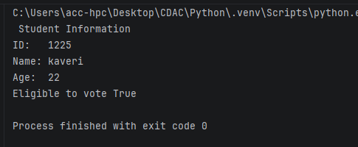
Q-2
• Create a base class Vehicle with attributes: make, model, and year. The constructor should initialize these.
• Add a method display_info() that prints the basic vehicle information.
• Create a child class Car that inherits from Vehicle.
• The Car class should have an additional attribute num_doors. The constructor should take make, model, year, and num_doors.
• Override the display_info() method in the Car class to also include the number of doors.
• Create instances of both Vehicle and Car to demonstrate inheritance and method overriding.
class Vehicle:
def __init__(self, make, model, year):
self.make = make
self.model = model
self.year = year

def display_info(self):
print(f"Vehicle Info: {self.year} {self.make} {self.model}")

class Car(Vehicle):
def __init__(self, make, model, year, num_doors):
super().__init__(make, model, year)
self.num_doors = num_doors

def display_info(self):
print(f"Car Info: {self.year} {self.make} {self.model} | Doors: {self.num_doors}")

generic_vehicle = Vehicle("Yamaha", "MT-07", 2022)
print("Vehicle Instance")
generic_vehicle.display_info()

print()

my_car = Car("Toyota", "Camry", 2024, 4)
print("Car Instance")
my_car.display_info()

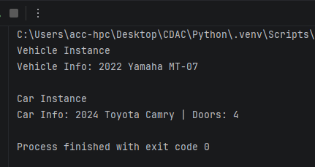
Q.3
• Employee Management System:
• Create a base class Employee with attributes name, employee_id, and salary.
• Create a derived class Manager that inherits from Employee and has an additional attribute for a list of employees they manage.
• Add methods to both classes, such as a method in Manager to add an employee to their managed list.
class Employee:
def __init__(self, name, employee_id, salary):
self.name = name
self.employee_id = employee_id
self.salary = salary

def display_info(self):
print(f"ID: {self.employee_id} | Name: {self.name} | Salary: {self.salary:,}")

class Manager(Employee):
def __init__(self, name, employee_id, salary):
super().__init__(name, employee_id, salary)
self.team = []

def add_employee(self, employee):
if isinstance(employee, Employee):
self.team.append(employee)
print(f"Added {employee.name} (ID: {employee.employee_id}) to {self.name}'s team.")
else:
print("Only instances of Employee can be added.")

def remove_employee(self, employee_id):
for emp in self.team:
if emp.employee_id == employee_id:
self.team.remove(emp)
print(f"Removed {emp.name} from {self.name}'s team.")
return
print(f"Employee ID {employee_id} not found in team.")

def display_info(self):
super().display_info()
print(f"Managed Team ({len(self.team)} member/s):")
if self.team:
for member in self.team:
print(f" - {member.name} (ID: {member.employee_id})")
else:
print(" - No team members assigned yet.")

emp1 = Employee("Kaveri Jarhad", "E101", 65000)
emp2 = Employee("Shubhang Khavle", "E102", 58000)

mgr = Manager("Tanvi Pawar", "M001", 95000)

print("Initial Manager Info")
mgr.display_info()

print("\nAdding Employees to Manager's Team ")
mgr.add_employee(emp1)
mgr.add_employee(emp2)

print("\nUpdated Manager Info")
mgr.display_info()

print("\n Removing an Employee")
mgr.remove_employee("E101")

print("\nFinal Manager Info ")
mgr.display_info()

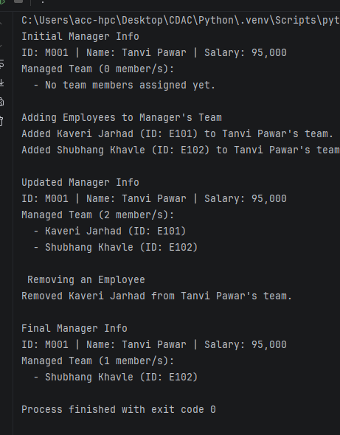
Q.4
Library Management System:
• Create a Book class with attributes like title, author, and is_available.
• Create a Library class that has a list of Book objects.
• Add methods to the Library class to:
o add_book(book): Adds a new book to the library's collection.
o borrow_book(title): Finds a book by title and changes its availability status.
o return_book(title): Changes a book's availability status back to available.
o display_available_books(): Prints the titles and authors of all available books.
class Book:
def __init__(self, title, author):
self.title = title
self.author = author
self.is_available = True

def __str__(self):
status = "Available" if self.is_available else "Borrowed"
return f"'{self.title}' by {self.author} [{status}]"

class Library:
def __init__(self):
self.books = []

def add_book(self, book):
if isinstance(book, Book):
self.books.append(book)
print(f"Added to library: '{book.title}' by {book.author}")
else:
print("Invalid item: Only instances of Book can be added.")

def borrow_book(self, title):
for book in self.books:
if book.title.lower() == title.lower():
if book.is_available:
book.is_available = False
print(f"Successfully borrowed: '{book.title}'")
else:
print(f"Sorry, '{book.title}' is currently checked out.")
return
print(f"Book titled '{title}' was not found in the library.")

def return_book(self, title):
for book in self.books:
if book.title.lower() == title.lower():
if not book.is_available:
book.is_available = True
print(f"Successfully returned: '{book.title}'")
else:
print(f"'{book.title}' was not borrowed.")
return
print(f"Book titled '{title}' was not found in the library.")

def display_available_books(self):
available_books = [book for book in self.books if book.is_available]

print("\nAvailable Books")
if available_books:
for book in available_books:
print(f"• '{book.title}' by {book.author}")
else:
print("No books are currently available.")

city_library = Library()

b1 = Book("1984", "George Orwell")
b2 = Book("To Kill a Mockingbird", "Harper Lee")
b3 = Book("The Great Gatsby", "F. Scott Fitzgerald")

city_library.add_book(b1)
city_library.add_book(b2)
city_library.add_book(b3)

city_library.display_available_books()

city_library.borrow_book("1984")
city_library.borrow_book("1984")

city_library.display_available_books()

city_library.return_book("1984")

city_library.display_available_books()

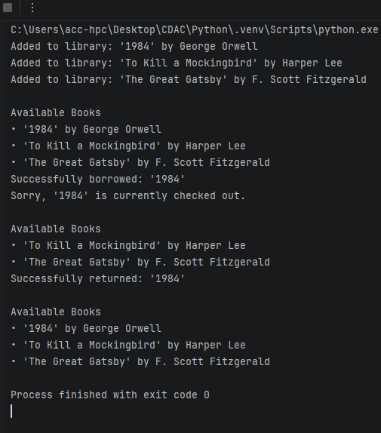

Q.5 Write a Python function is_valid_phone(text) that takes a string and returns True if it is a valid 10-digit phone number, and False otherwise. A valid phone number should consist of exactly 10 digits.
def is_valid_phone(text):
return len(text) == 10 and text.isdigit()

print(is_valid_phone("9876543210"))
print(is_valid_phone("987654321"))
print(is_valid_phone("98765432100"))
print(is_valid_phone("98765abcde"))

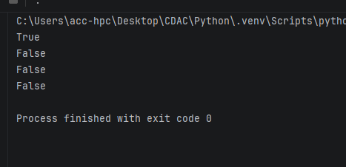
Q.6 Write a Python program to find all words in a string that start with the letter 'p' (case-insensitive) and are at least 3 characters long.
import re

def find_p_words(text):
pattern = r'\b[pP]\w{2,}\b'
return re.findall(pattern, text)

sample_text = "I picked a pair of purple pencils, but pop was too short."
result = find_p_words(sample_text)
print(result)

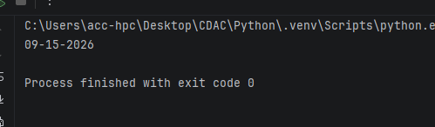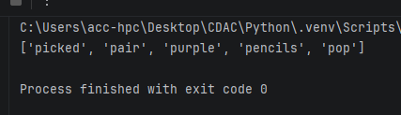
Q.7 Write a Python function find_dates(text) to find the first occurrence of a date in the format MM-DD-YYYY and prints the full match.
import re

def find_dates(text):
pattern = r'\b(0[1-9]|1[0-2])-(0[1-9]|[12][0-9]|3[01])-\d{4}\b'
match = re.search(pattern, text)
if match:
print(match.group())

sample_text = "The Lecture is scheduled for 09-15-2026, and the backup date is 10-20-2026."
find_dates(sample_text)

Q.8 Write a Python function is_strong_password(password) that uses regex to check if a password meets the following criteria:
• At least 8 characters long.
• Contains at least one uppercase letter.
• Contains at least one lowercase letter.
• Contains at least one digit.
• Contains at least one special character (e.g., !, @, #, $, %, ^, &, *).
def is_strong_password(password: str) -> bool:
if len(password) < 8:
return False

has_upper = False
has_lower = False
has_digit = False
has_special = False

special_characters = "!@#$%^&*(),.?\":{}|<>"

for char in password:
if char.isupper():
has_upper = True
elif char.islower():
has_lower = True
elif char.isdigit():
has_digit = True
elif char in special_characters:
has_special = True

return has_upper and has_lower and has_digit and has_special

user_password = input("Enter a password: ")

if is_strong_password(user_password):
print("Strong Password!")
else:
print(
"Weak Password! Must contain at least 8 characters, an uppercase letter, a lowercase letter, a digit, and a special character.")

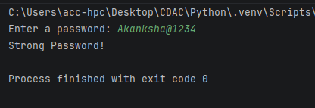
Q.9 Write a Python function clean_string(text) that takes a string and performs the following cleaning tasks using regex:
• Replace multiple spaces with a single space.
• Remove leading and trailing whitespace.
• Capitalize the first letter of each sentence.
def clean_string(text: str) -> str:
cleaned = " ".join(text.split())

sentences = cleaned.split(". ")
capitalized_sentences = []

for sentence in sentences:
if sentence:
capitalized_sentences.append(sentence[0].upper() + sentence[1:])

return ". ".join(capitalized_sentences)

sample_text = " hello world. how are you "
print(clean_string(sample_text))

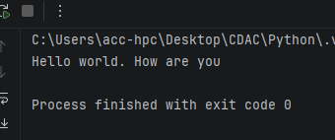n

Q.10 Write a Python program that takes a string and replace all punctuation marks (e.g., ,, ., !, ?) with an empty string.
def remove_punctuation(text: str) -> str:
punctuation = "!\"#$%&'()*+,-./:;<=>?@[\\]^_`{|}~"
result = ""

for char in text:
if char not in punctuation:
result += char

return result

user_input = input("Enter a string: ")
print("Result:", remove_punctuation(user_input))

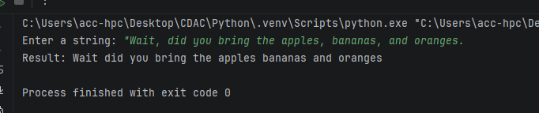
Q. 11 Read and Print a File:
• Create a text file named data.txt with a few lines of text.
• Write a Python script that opens data.txt in read mode, reads the entire content, and prints it to the console.
• Make sure to use a with statement to handle the file automatically.
• Count Lines in a File:
• Use the data.txt file from the previous question.
• Write a Python program that counts the number of lines in the file and prints the total count.
• Append to a File:
with open("data.txt", "w") as file:
file.write("Hello, world!\nWelcome to Python file handling.\nThis is line three.")

print("Reading File")
with open("data.txt", "r") as file:
content = file.read()
print(content)

with open("data.txt", "r") as file:
lines = file.readlines()
line_count = len(lines)

print("\nLine Count")
print("Total lines:", line_count)

with open("data.txt", "a") as file:
file.write("\nThis line was appended to the file.")

print("\nUpdated File Content")
with open("data.txt", "r") as file:
print(file.read())

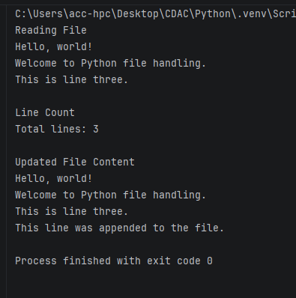
Q 12 Create a file named log.txt.
• Write a Python program that prompts the user to enter a log message.
• The program should then append this message, along with a timestamp, to the end of log.txt on a new line.
from datetime import datetime

message = input("Enter a log message: ")
timestamp = datetime.now().strftime("%Y-%m-%d %H:%M:%S")

with open("log.txt", "a") as file:
file.write(f"[{timestamp}] {message}\n")

print("Log entry saved to log.txt")
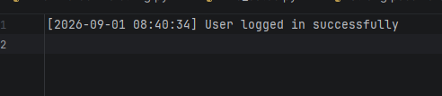
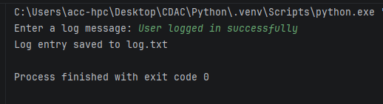
Q 13 Write a Simple CSV File:
• Write a Python script that takes a list of lists, where each inner list represents a row of data (e.g., [['Name', 'Age'], ['Alice', 30], ['John', 25]]).
• The script should write this data to a new CSV file named people.csv.
• Use the csv module for this task.
import csv

data = [
['Name', 'Age'],
['Kaveri', 21],
['Shubhangi', 22]
]

with open('people.csv', 'w', newline='') as file:
writer = csv.writer(file)
writer.writerows(data)

print("Data written to people.csv successfully.")

